

Neuromechanics Laboratory

Intention Detection Documentation

Directed by Dr. Li-Qun Zhang

Supervised by Giovanni Oppizzi

Contents

Introduction 3

Technical Documentation 3

Placing the Armband 3

Connecting Armband 3

Hand of Hope Interface 4

Processes Flow Chart 5

User Guide 6

Function Reference 12

Collecting data 12

Training model 12

Testing patient 12

Assigning a new prompt 12

Assigning a random prompt 12

Assigning a prompt of random length 12

Setting training classes 12

Setting time interval 12

Clearing data 12

Clearing model 12

Assigning channels 12

Displaying raw data 12

Displaying rectified data 12

Displaying normalized data 12

Connecting to LabView backend 12

Troubleshooting 13

Resources 14

# Introduction

The Electromyography (EMG) Intention Detection is a system developed in the Neuromechanics Laboratory with the intended use for stroke rehabilitation and patient training. The person operating the program will be administering the test and will be referred to as the *user*. The person whose EMG is being recorded, and who will receive treatment will be referred to as the *patient* from this point. There are three primary functions of the application:

1. Collect EMG data from the patient using the MindRove Armband.
2. Train a model that represents a profile for the patient using a given data set.
3. Use the model to predict the intention of a patient via new data fed into the system, and relay to the HoH to assist the patient.

The Mindrove Armband is an 8-channel low cost surface EMG (sEmg) system that can be connected to a computer running the Intention Detection program via Wi-Fi. sEMG data is streamed to the computer and processed automatically for the machine learning (ML) model. There are a few options for the user to parse the data before training a model. The model is an Artificial Neural Network and will accept the EMG data as the input and produce the associated pose for the output.

Once a model has been trained and validated, it can be used to test and train the patient. The user can create a series of poses that the patient must try and perform. For each pose, the system will collect a new data set from the patient and validate it. If it is the correct pose, the Hand of Hope will assist the patient. The patient must be intentional when creating the pose as this will provide a stronger reinforcement.

# Technical Documentation

The application communicates with two systems to create a closed environment. It will stream data from the MindRove Armband as well as relay commands to the HoH robot.

## Placing the Armband

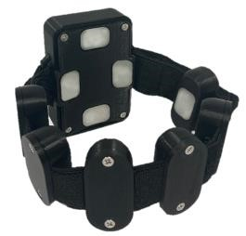A secure fit and clean contact between the leads of the armband and the skin will ensure that data is properly collected. Before placing the armband on the patient, use an alcohol wipe to clean the surface of the leads, as well as the skin of the patient. Take care not to touch the contacts after cleaning them. Do not stretch the armband over the patient’s forearm, as this may damage the wires connecting the leads. Instead, undo the clasp to create enough slack in the armband that it goes over the patient’s forearm with little to no resistance. Position the main lead of the armband over the ulna, or bony, part of the forearm.

Take note of the placement of the armband, as placement in future *Figure 1: MindRove Armband* sessions must be the same for each patient.

## Connecting Armband

To connect with the armband, first turn on the device. The three LEDs will flash green, red, and blue before turning a steady green. Then search for the device in the available Wi-Fi networks. It will appear as “MindRove_ARB_<Serial>” where the last part is a serial code. An example of how appears is shown below. If a password is required, use *#mindrove*.

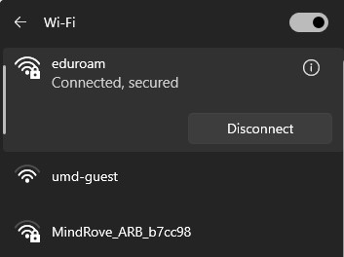

*Figure 2: Example of the MindRove Armband appearing in the available Wi-Fi networks.*

## Hand of Hope Interface

The HoH will be connected via a microcontroller that relays commands to a separate computer system running the in-house-built LabView software. When training a patient, data will be collected from the patient using the armband. This data is then processed and fed into the model which outputs the pose. This is communicated to the microcontroller, which sends a signal to the LabView backend that codes for the position. The backend controls the HoH, which then moves to the same pose that the patient was trying to create.

## Processes Flow Chart



Start Program



Connect to

MindRove

Armband



Load Data



Collect

Data



Load Model



Retrain Model



Train New



Export Model



Export



Train Patient



LabView

Back

End



HoH



Collect New



Test Model



***Arduino***

# User Guide

The first thing that the user sees when opening the application is the main tab, which hosts the three principal functions of the program. The main tab also includes an instruction panel, a status bar located at the bottom of the window that displays temporary messages, a status panel that displays the training prompt, the filename for the data and model, and the status of the MindRove and LabView connection, and options to configure the port.

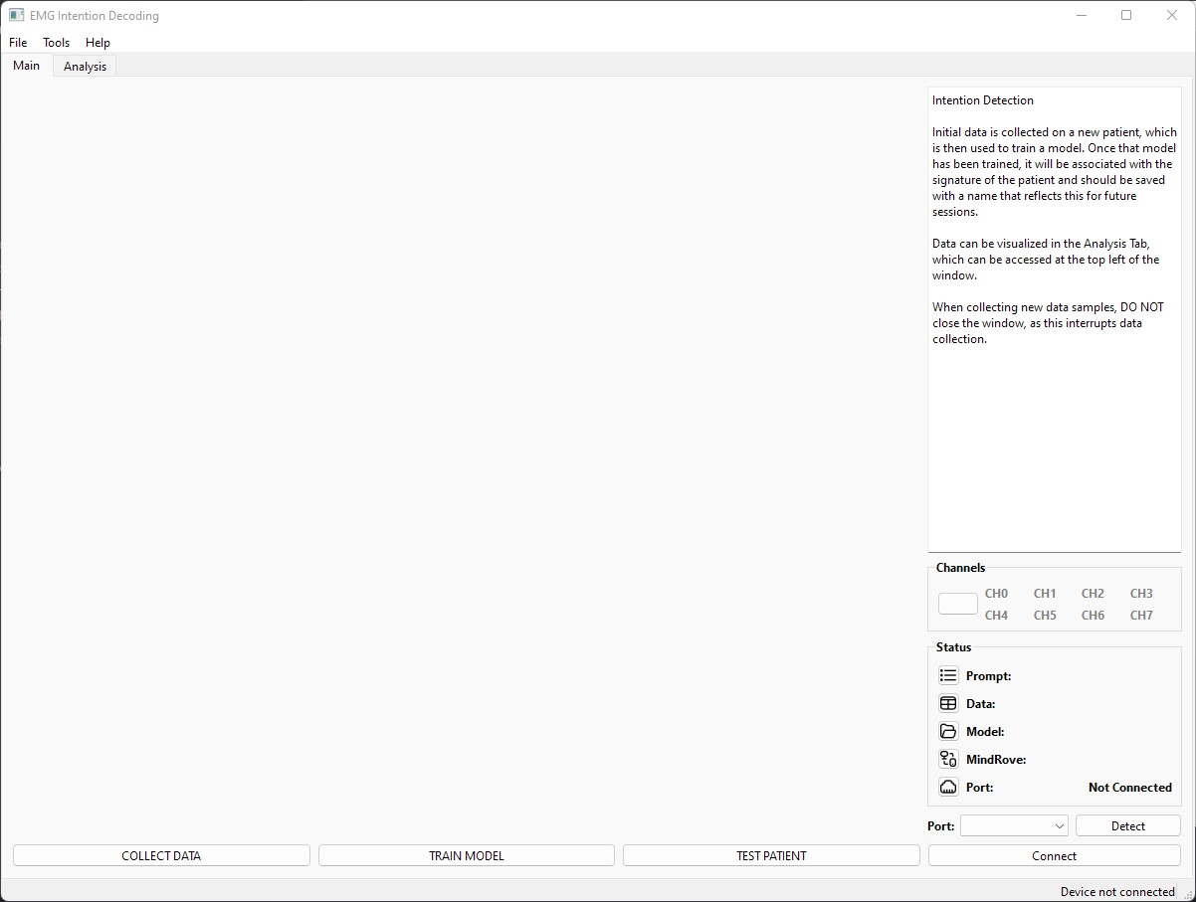

Instruction Panel

Training

Functions

Menu Bar

Status

Panel

Tabs

*Figure 3: Main tab of the EMG Intention Detection program.*

There are three primary functions that are located at the bottom of the main tab. The button on the left will initiate communication between the MindRove Armband and the program. This streams and processes the data, which includes filtering and rectifying the data.

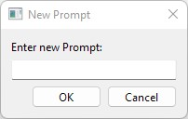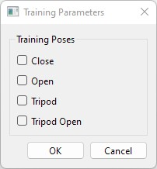To collect data from the patient, the user must select the training prompt. There are several ways to do this, but two are preferred. First, the user may create the prompt by selecting **Prompt**→ **New Prompt…** from the **Tools** on the menu bar. This opens a dialogue to create a new prompt up to 30 poses in length. The second, and preferred, option is to select the training prompt. This can be found by selecting **Training Parameters** from the **Tools** menu. This will open a dialogue to select the poses the user wants the patient to train on. There are 16 repetitions for each pose, with a resting pose in between for a total of 32 for each pose. The available poses are shown in **Table 1**. The EMG Intention Detection system will only recognize the ID of each pose, so the user should input the prompt using only the assocated ID e.g. 0 codes for rest.

*Table 1: Poses available for training. When assigning a prompt, use the number that is associated with that pose e.g. 0 assigns the pose 'rest’.*

|  |  |  |  |
| --- | --- | --- | --- |
| *Pose 0: rest* | *Pose 1: close* | | *Pose 2: open* |
| *Pose 3: tripod* |  |  | *Pose 4: tripod open* |

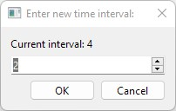Once the prompt has been created, the user can begin collecting EMG data from the patient. When **Collect Data** is initiated, there is a 5 second countdown to prepare the patient. The first pose will always be “rest” to let the patient see how the interface looks. When each subsequent pose appears, the patient should try to create the pose to the best of their abilities, being as swift and intent as possible. The poses appear according to a timer that is set to 4 seconds. If the patient needs a different time, the interval can be changed under the **Tools** menu using **Set Time Interval**. This opens a dialogue that also shows the current interval.

NOTE: In the future, the interval will be easier to access/view in the main tab.

When the data has

been collected

, a prompt will appear that asks

the user to create a new filename.

If the user selects no, then the data

will be saved

in the home directory

as a csv file with the timestamp in

the

name e.g.

**emg_data20231215122555.csv**

.

If the user selects yes,

then they can create a new name

and save the file in any locat

ion.

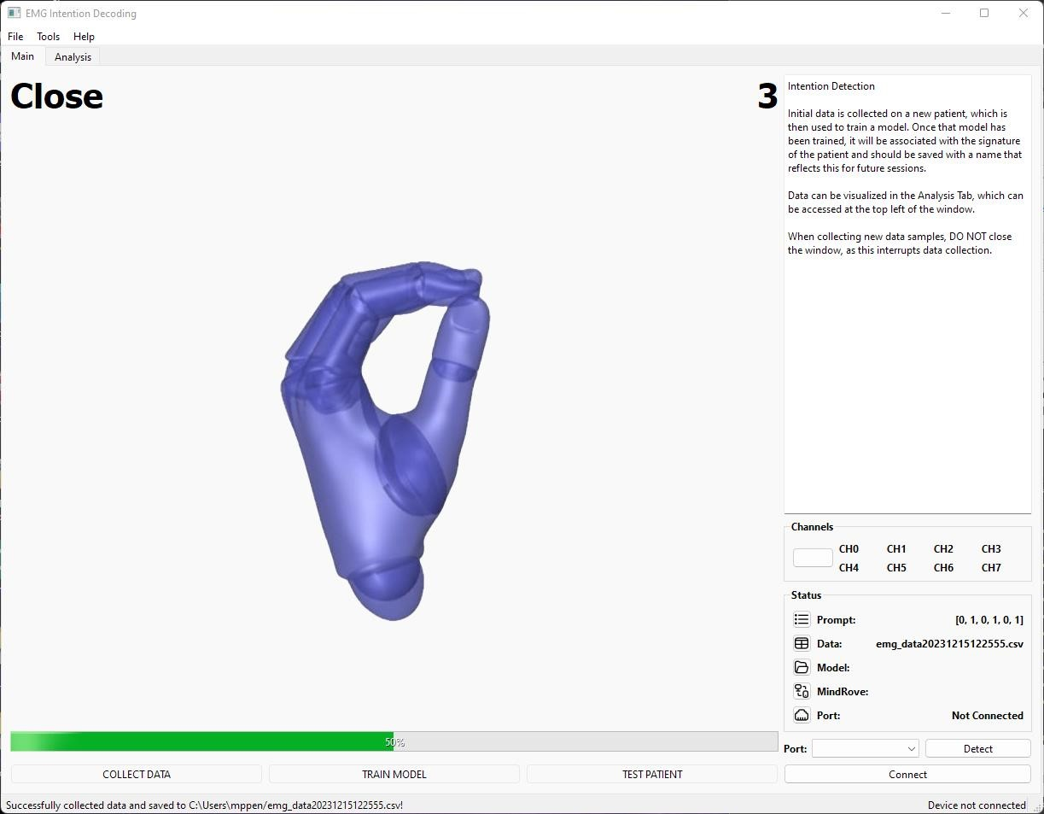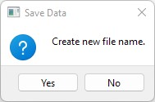

**Current Pose**



**Interval**

*Figure 4: Example of the UI while collecting data. The interval is displayed in the top right pf the window, and the current pose is displayed in the top left.*

Before training the model, the user must verify that all the channels are working as intended. The data can be viewed in the Analysis Tab which is in the top left of the window. This contains plots of the 8 channels from the armband, as well as a plot of the poses. The rectified data is displayed once it has been collected from the patient and should appear as shown in **Figure 5**. If any channel does not have the desired shape, it can be excluded when training by selecting the checkboxes in the right of the window and pressing **Set Channels**. The selected channels can also be viewed in the main tab. Spikes may occur in the channels, which distorts the signal and decreases the accuracy when training the model. This can be limited by cleaning the leads and skin of the patient, and by ensuring a snug fit so that the leads maintain contact. However, if a clean signal cannot be achieved, it is better to exclude it from training. Take note of the channel that was excluded for future sessions with the same patient.

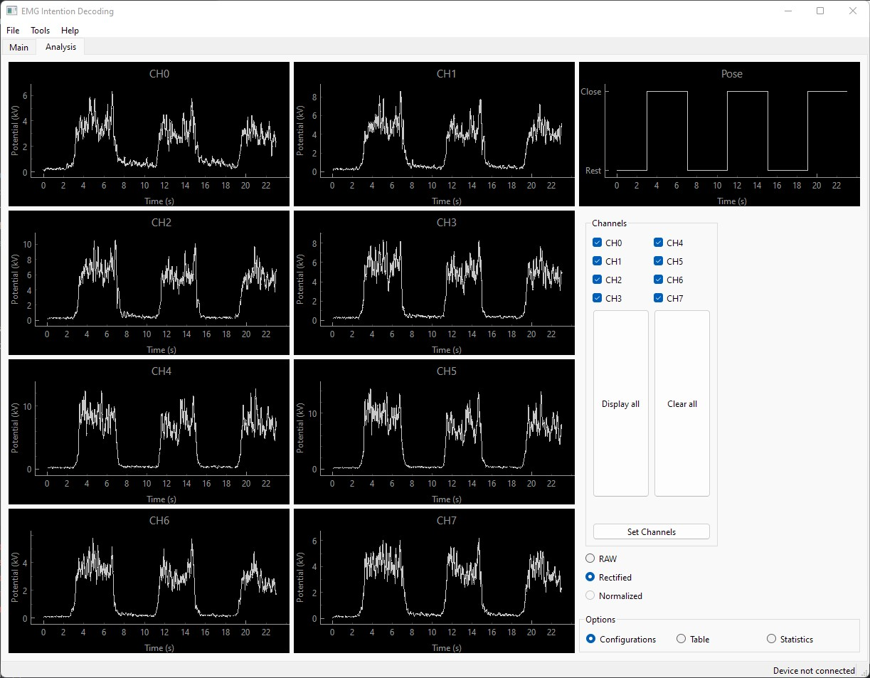

*Figure 5: Example of the Analysis Tab displaying rectified data. The data that appears is a clear example of how it should look when training the model.*

Once the channels have been selected, the model can be trained. It is an automated process and will begin when pressing **Train Model**. This is a background task and will take several minutes. Currently, there is no function to monitor the progress of training from the User Interface; however, it can be viewed in the terminal.

After the model has been trained, a prompt will appear to name it.

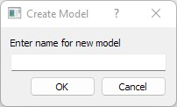

The model will then be saved in a folder. Make sure there is a folder titled *Models*. It should be in the same folder as the main program. The accuracy of the model can be viewed from the analysis tab.

The final task is to test the patient using the newly built model…

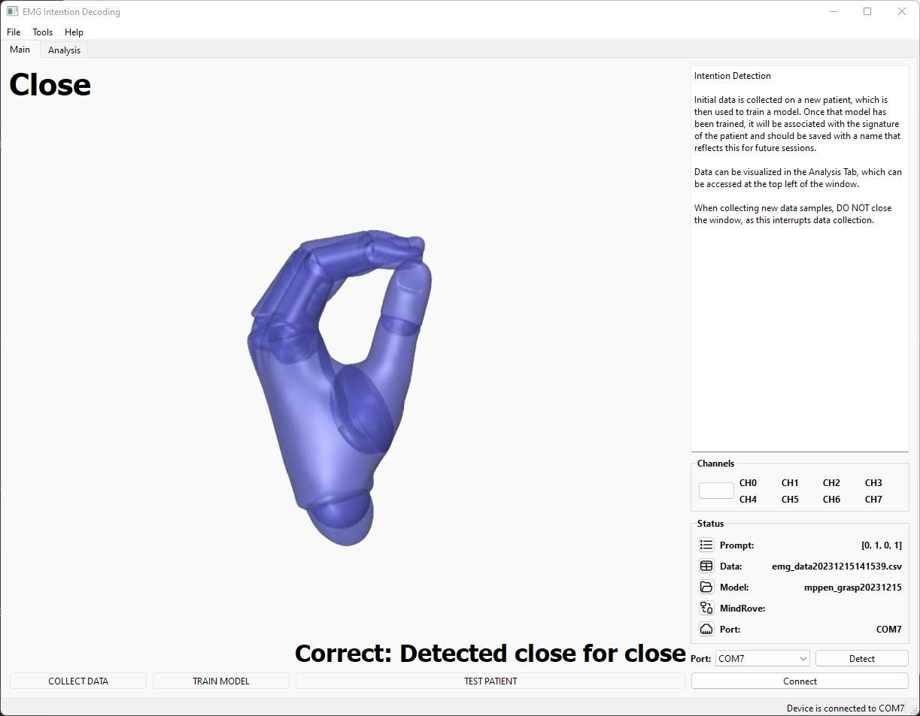

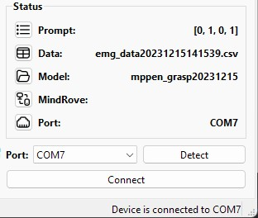

# Function Reference

## Collecting data

## Training model

## Testing patient

## Assigning a new prompt

## Assigning a random prompt

## Assigning a prompt of random length

## Setting training classes

## Setting time interval

## Clearing data

## Clearing model

## Assigning channels

## Displaying raw data

## Displaying rectified data

## Displaying normalized data

## Connecting to LabView backend

# Troubleshooting

# Resources

The following links provide the documentation for the MindRove Armband.

1. <https://mindrove.com/armband/>2. <https://docs.mindrove.com/Troubleshoot.html>

3.